**RegEx:**In SQL, regular expressions (regex) can be used for pattern matching within string data. The REGEX operator is typically used for this purpose. However, it's important to note that the exact syntax may vary depending on the SQL database.

|  |  |
| --- | --- |
| * | Zero or more instances of string preceding it |
| + | One or more instances of strings preceding it |
| . | Any single character |
| ? | Match zero or one instances of the strings preceding it. |
| ^ | caret(^) matches Beginning of string |
| $ | End of string |
| [abc] | Any character listed between the square brackets |
| [^abc] | Any character not listed between the square brackets |
| [A-Z] | match any upper case letter. |
| [a-z] | match any lower case letter |
| [0-9] | match any digit from 0 through to 9. |
| [[:<:]] | matches the beginning of words. |
| [[:>:]] | matches the end of words. |
| [:class:] | matches a character class i.e. [:alpha:] to match letters, [:space:] to match white space, [:punct:] is match punctuations and [:upper:] for upper class letters. |
| p1|p2|p3 | Alternation; matches any of the patterns p1, p2, or p3 |
| {n} | n instances of preceding element |
| {m,n} | m through n instances of preceding element |

In ms sql server we only use like to identify expression. Here are some examples:

1. **‘%’:**

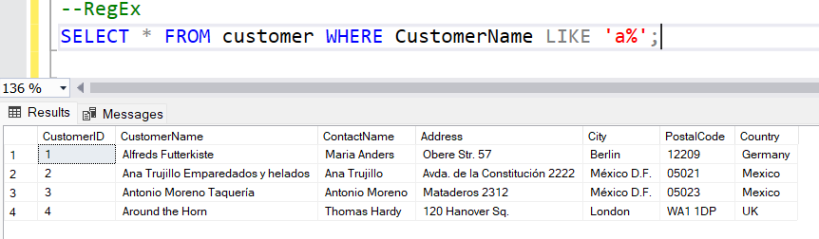

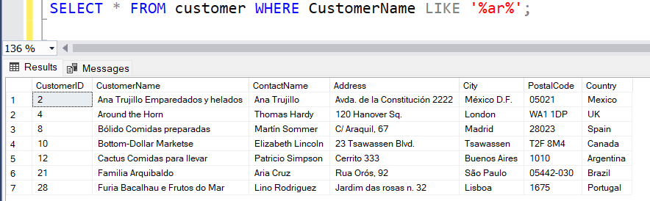

**c.** 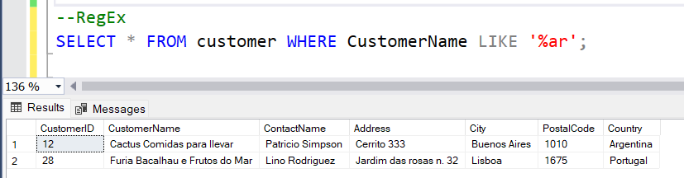

1. **‘_’:**

